**Practical No. 9**

**Aim: Email Forensics**

**- Mail Service Providers**

**- Email protocols**

**- Recovering emails**

**- Analyzing email header**

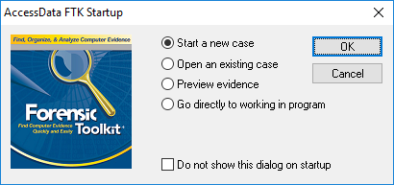

**When the AccessData FTK Startup dialog box opens, click Start a new case, and then click OK.**

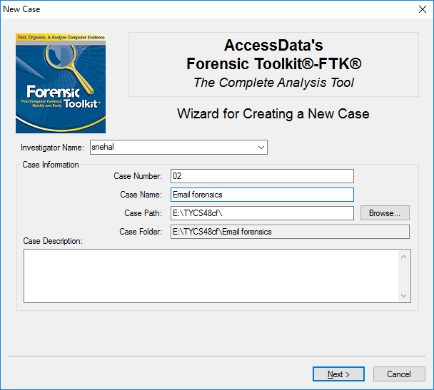

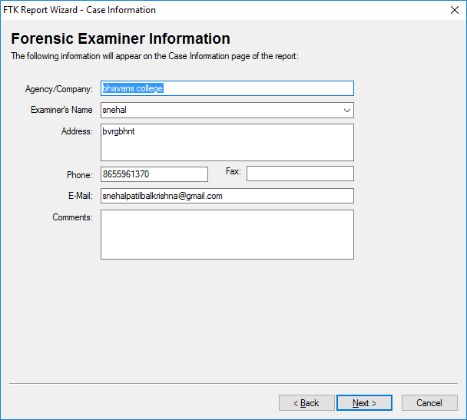

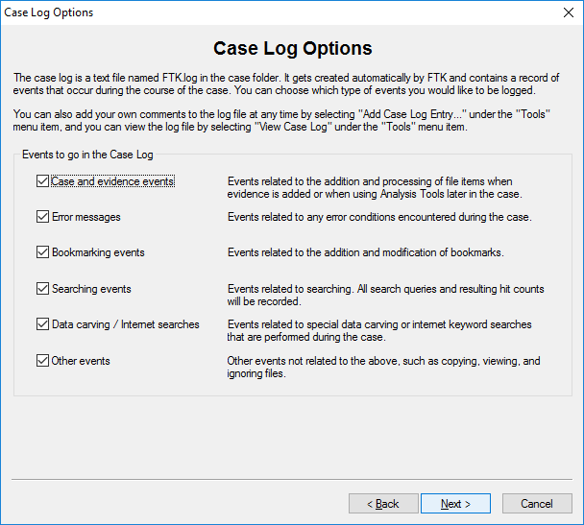

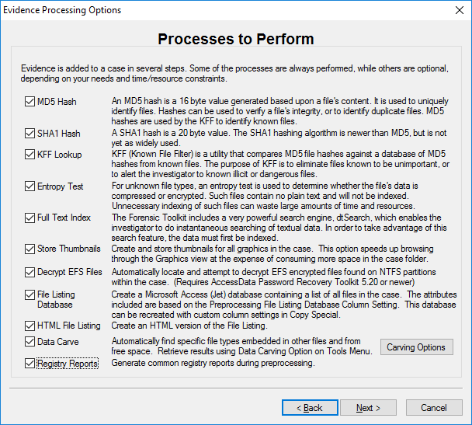

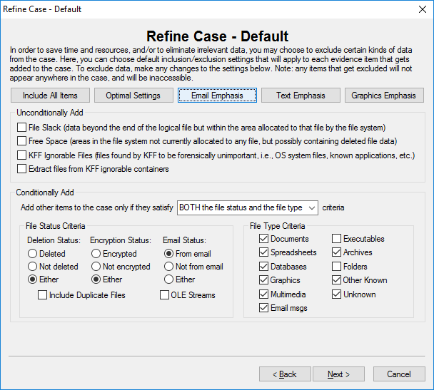

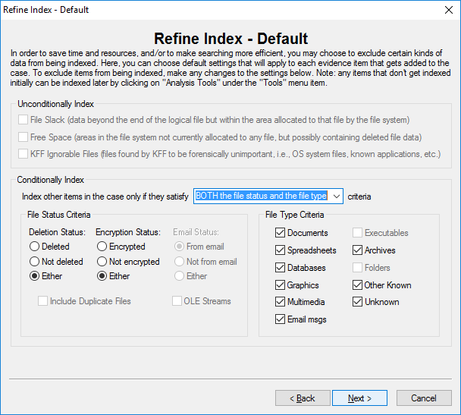

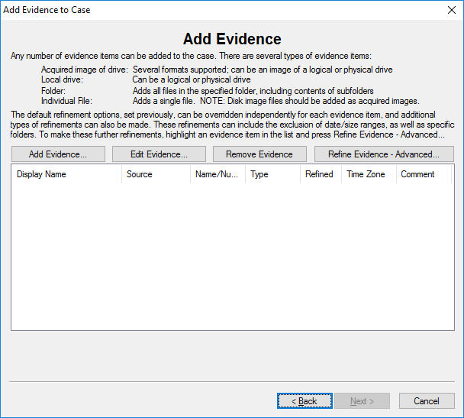

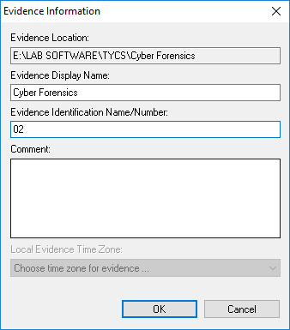

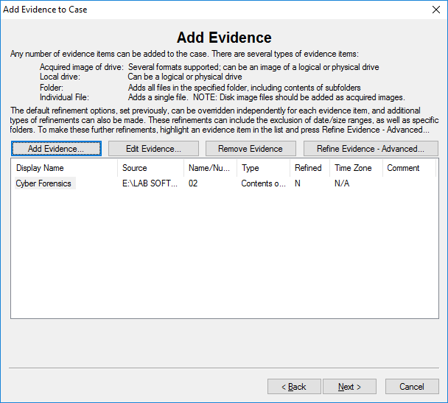

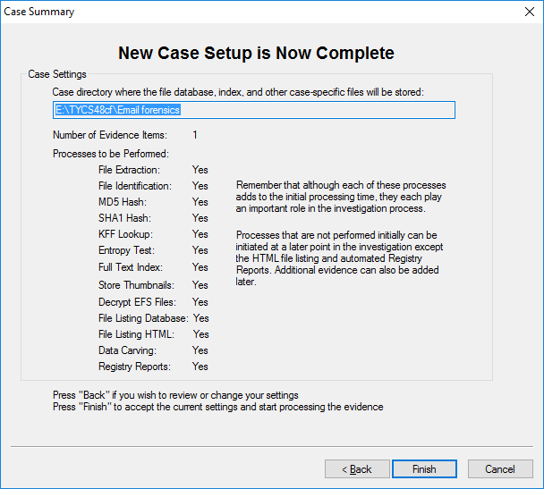

**When FTK finishes processing the file, in the main FTK window, click the E-mail Messages button, and then click the Full Path column header to sort the records**

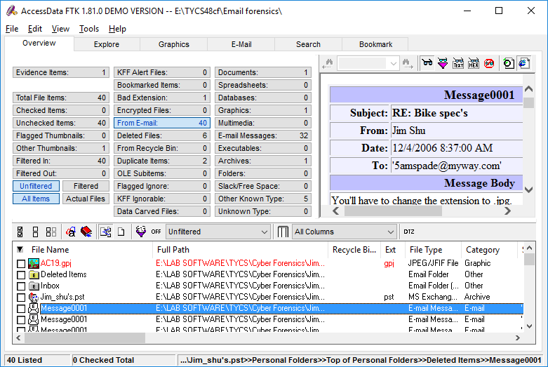

**For email recovery follow following steps:**

**1. Click the E-Mail tab. In the tree view, click to expand all folders, and then click the Deleted Items folder**

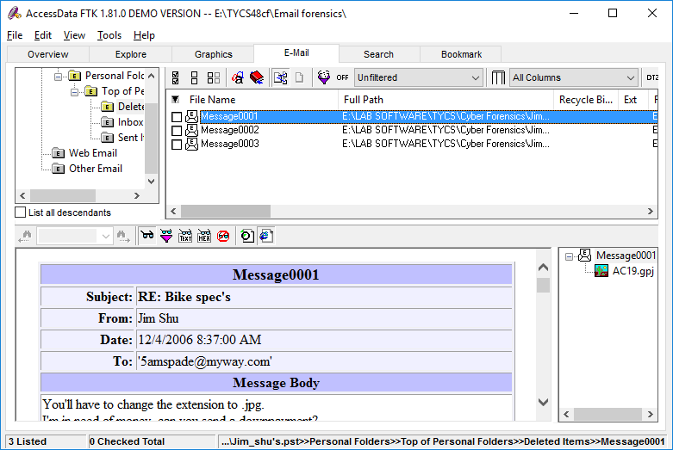

**2. Right-click Message0010 in the File List pane and click Export File. In the Export Files dialog box, click OK**

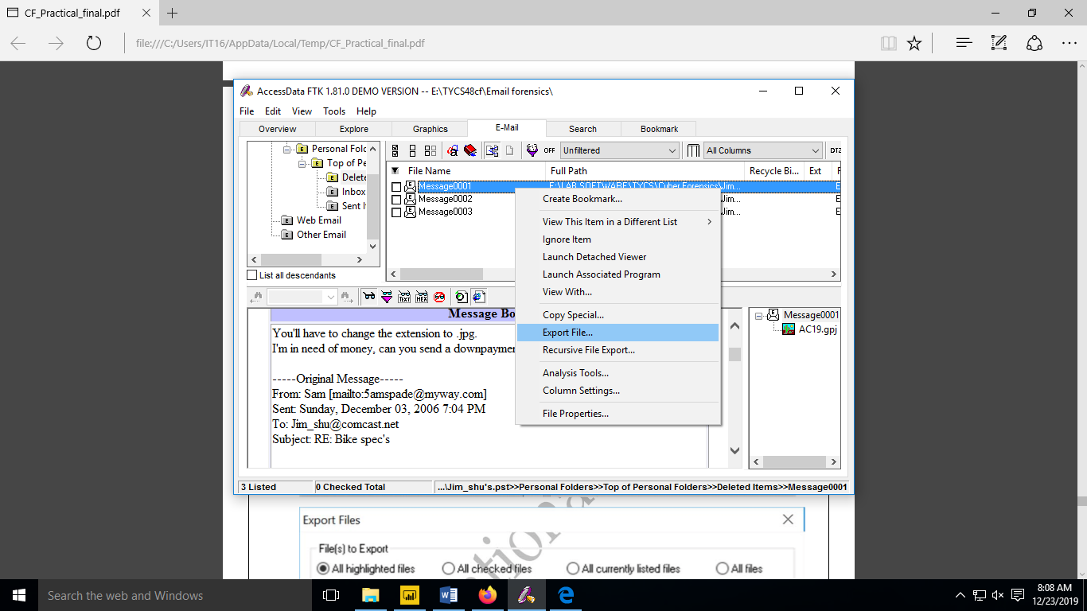

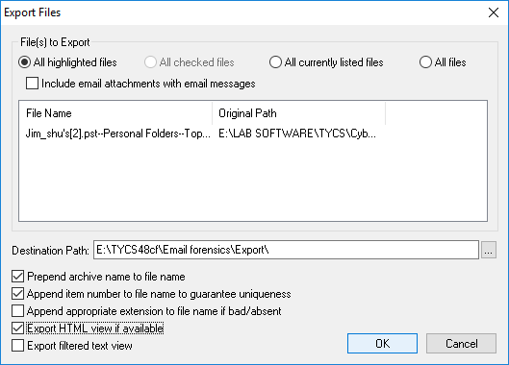

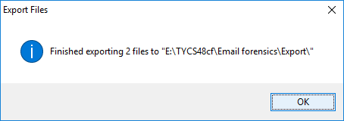

**3. Open the Export folder to view the Email Files, Open the HTML file in browser**

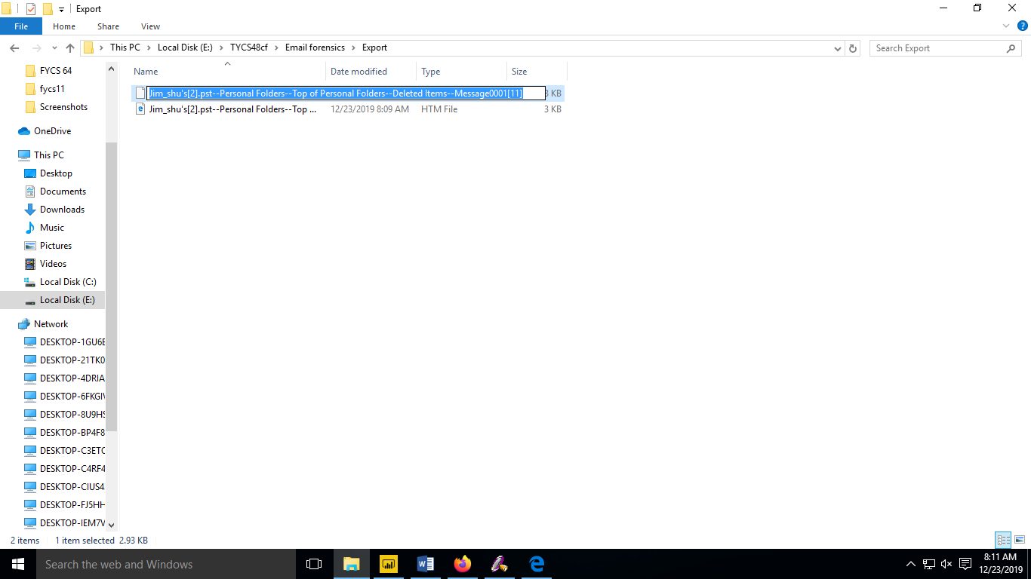

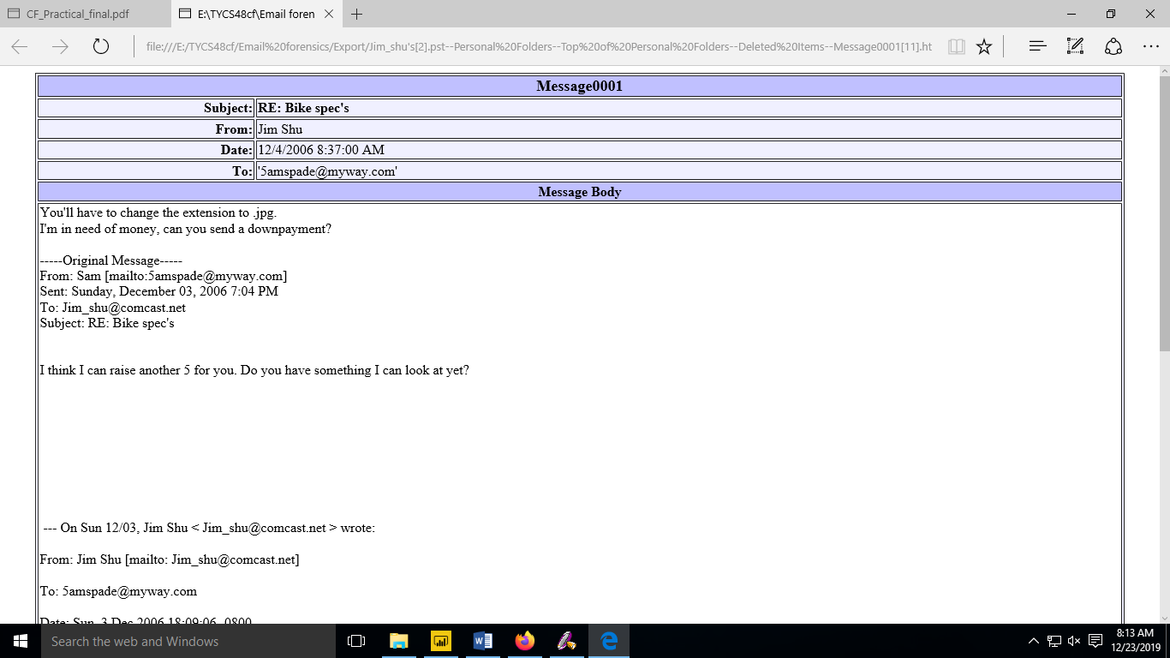

**For analyzing header follow following steps:**

**1. Right Click the file type and Open with firefox or chrome view header information**

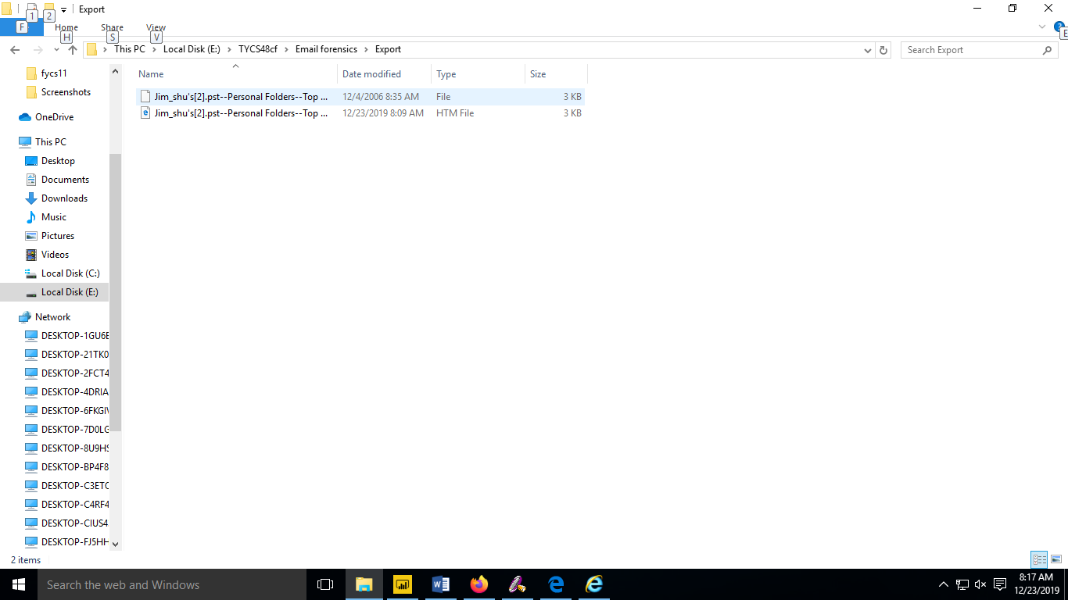

**Output:**

